

About Laravel: -

Laravel is a web application framework with expressive, elegant syntax. We believe development must be an enjoyable and creative experience to be truly fulfilling. Laravel takes the pain out of development by easing common tasks used in many web projects, such as:

* Simple, fast routing engine.
* Powerful dependency injection container.
* Multiple back-ends for session and cache storage.
* Expressive, intuitive database ORM.
* Database agnostic schema migrations.
* Robust background job processing.
* Real-time event broadcasting.

Laravel is accessible, powerful, and provides tools required for large, robust applications.

Learning Laravel: -

Laravel has the most extensive and thorough documentation and video tutorial library of all modern web application frameworks, making it a breeze to get started with the framework. Laracasts contains over 1500 video tutorials on a range of topics including Laravel, modern PHP, unit testing, and JavaScript. Boost your skills by digging into our comprehensive video library.

Laravel Sponsors: -

* **Vehikl**
* **Tighten Co.**
* **Kirschbaum Development Group**
* **64 Robots**
* **Cubet Techno Labs**
* **Cyber-Duck**
* **Many**
* **Webdock, Fast VPS Hosting**
* **DevSquad**
* UserInsights
* Fragrantica
* SOFTonSOFA
* User10
* Soumettre.fr
* CodeBrisk
* 1Forge
* TECPRESSO
* Runtime Converter
* WebL'Agence
* Invoice Ninja
* iMi digital
* Earthlink
* Steadfast Collective
* We Are the Robots Inc.
* Understand.io
* Abdel Elrafa
* Hyper Host
* Appoly
* OP.GG
* 云软科技

License: -

The Laravel framework is open-sourced software licensed under the MIT license.

Web Application using Laravel Framework: -

Being a sample project based on waterfall model, I have kept the naming minimal i.e <myapp.me> . It is a basic crud application based on the laravel framework. Here user can create own account, post some query and get solution by other registered user, let us discuss some of the features:

Storing the User Data: -

I used mysql-server with phpmyadmin to save all the user data in a particular user_id table:

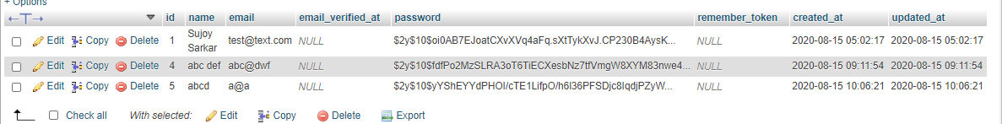

Storing user posts in the Data Base: -

Created a posts table which takes the values and arguments from the application and store that in the Data Base:

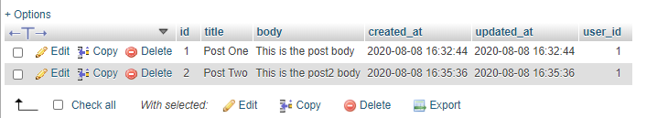

**High-level design: -**

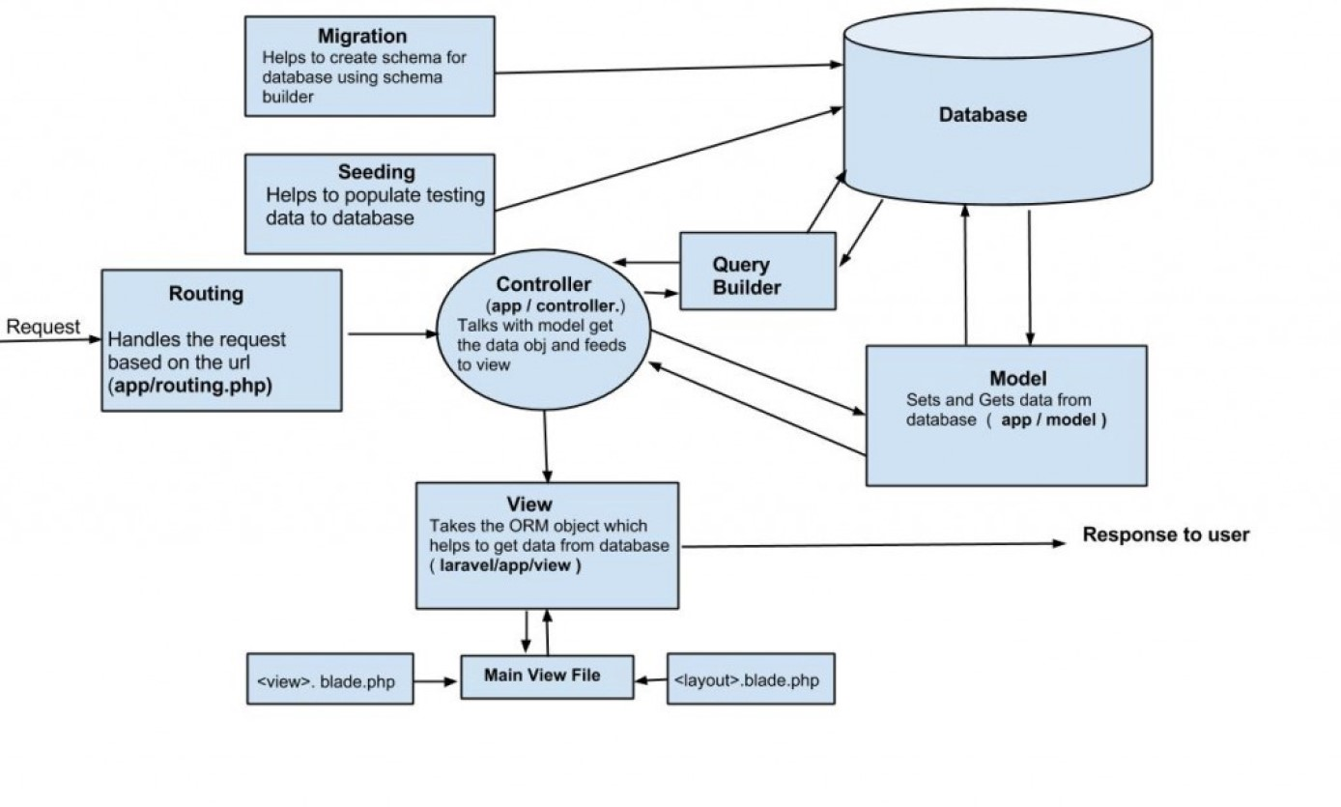

Future Scope: -

It’s just a bare-bones, I have planned to add more feature to this application with an active domain host, to make this a full-fledged forum website.

Challenges faced: -

I faced some good challenges during this whole session, but I have utilized all the time that Binary Folks has allocated to me. I have gone through most of the concepts of php-oop, html-5,

some basic css-3 and bootstrap-4, mysql and finally Laravel-7. Thanks for this opportunity.